Sign Up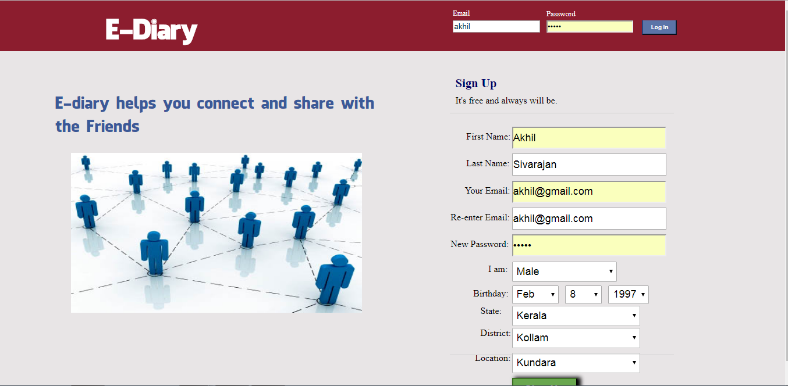
Admin Login

Home
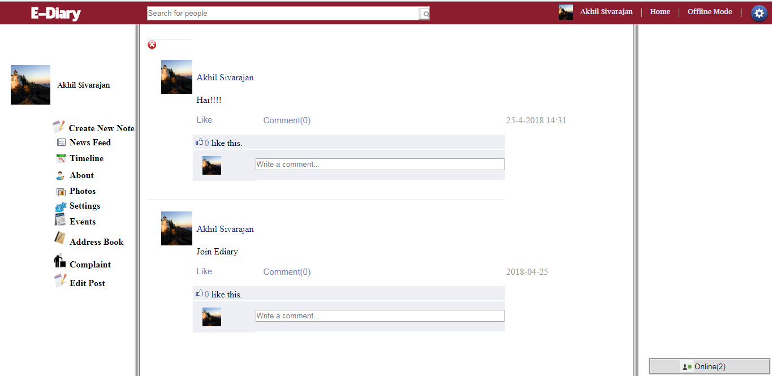
About
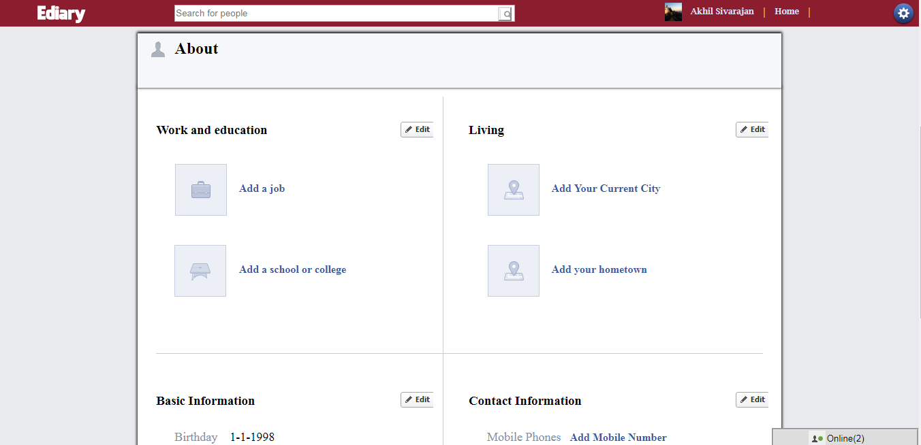
Profile
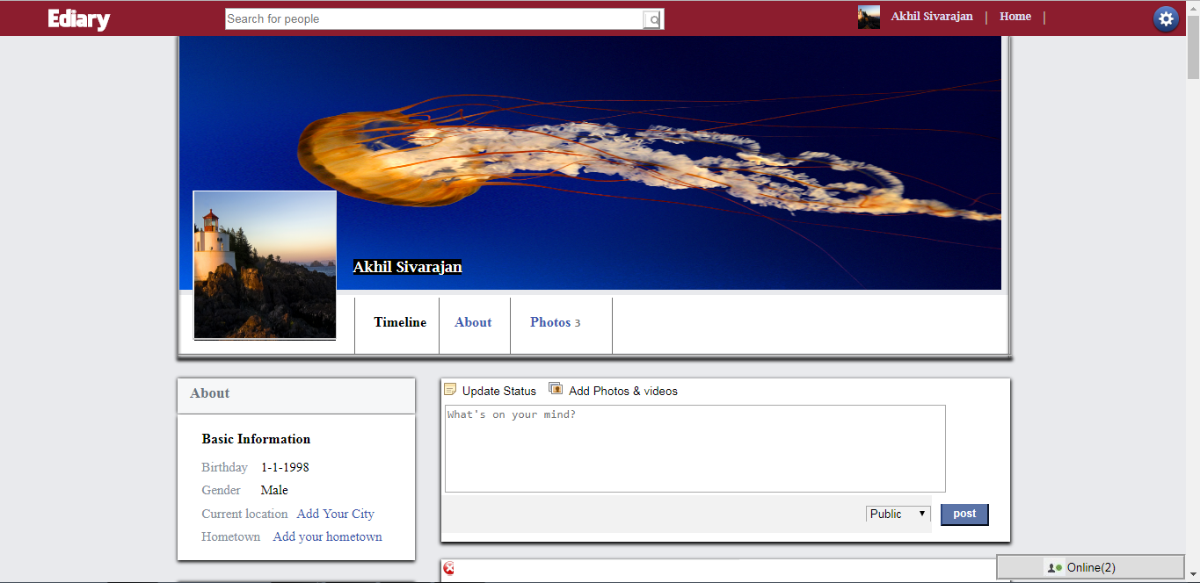
Events
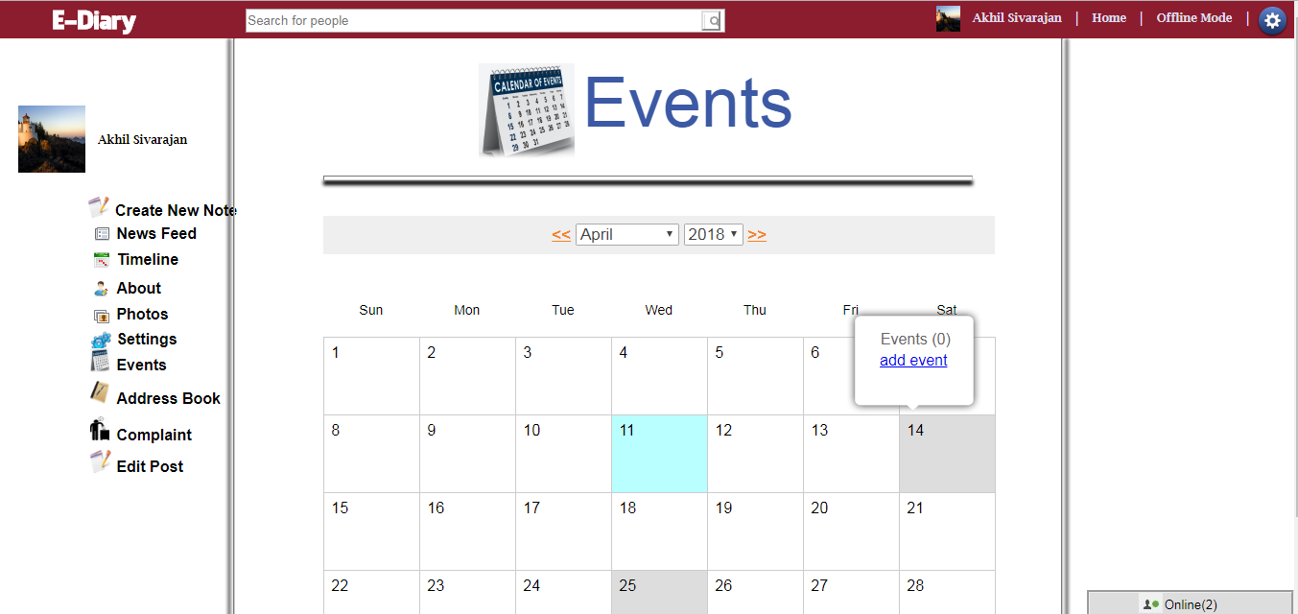
Contact
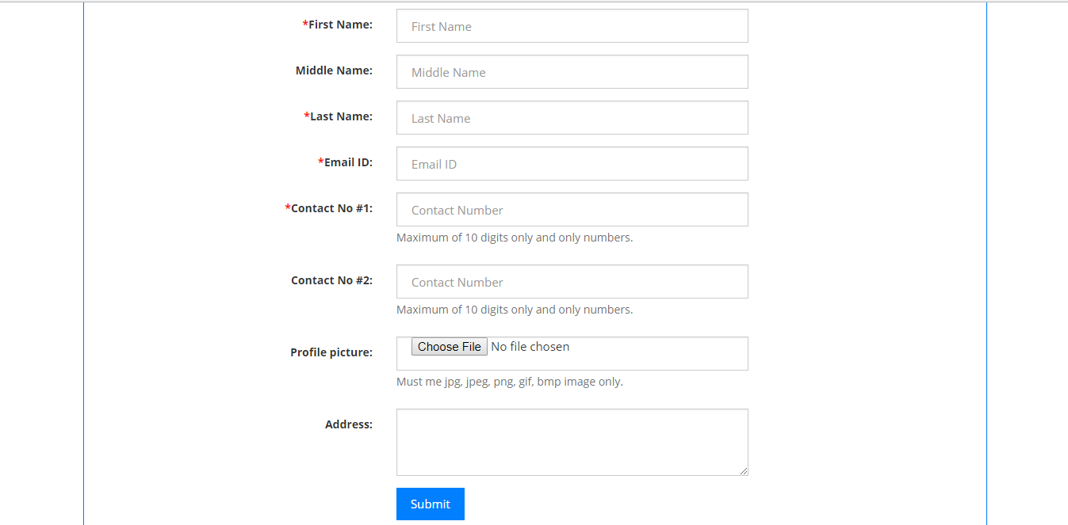
State
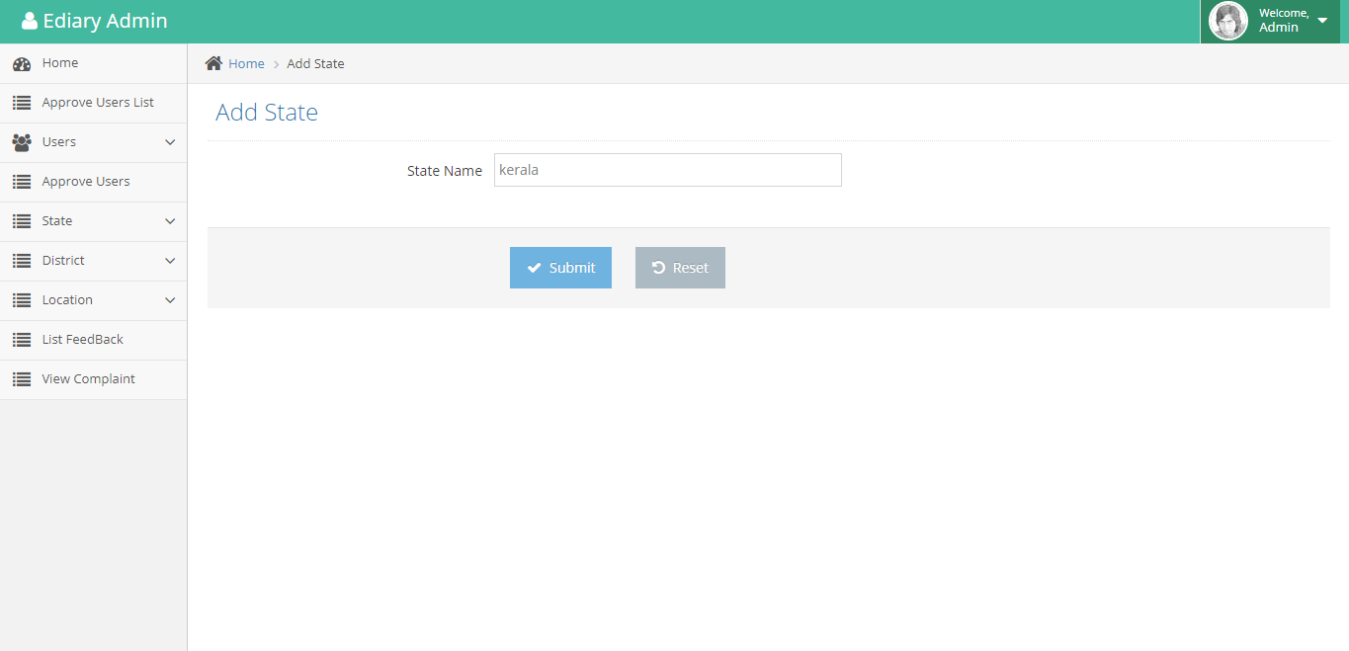
Add District
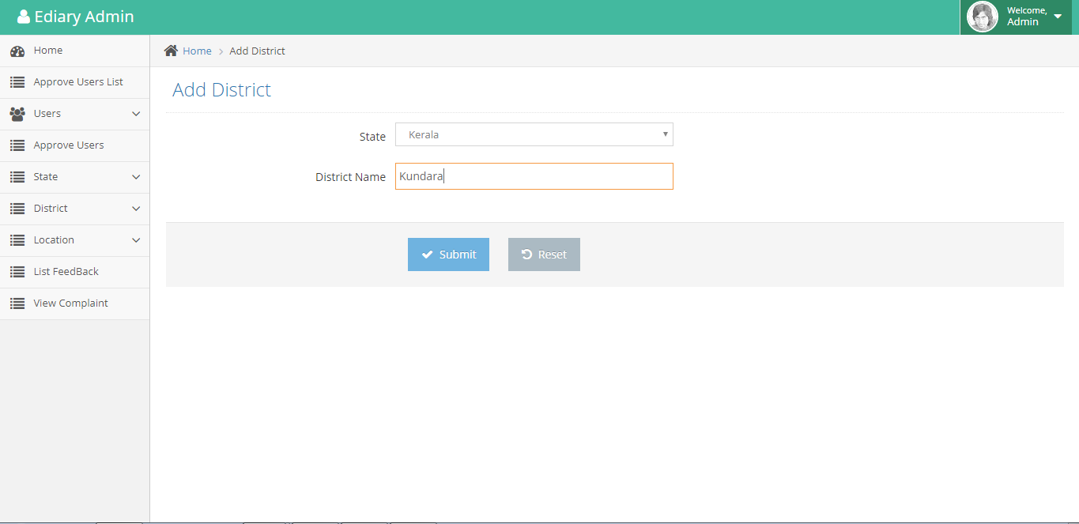
Add Location
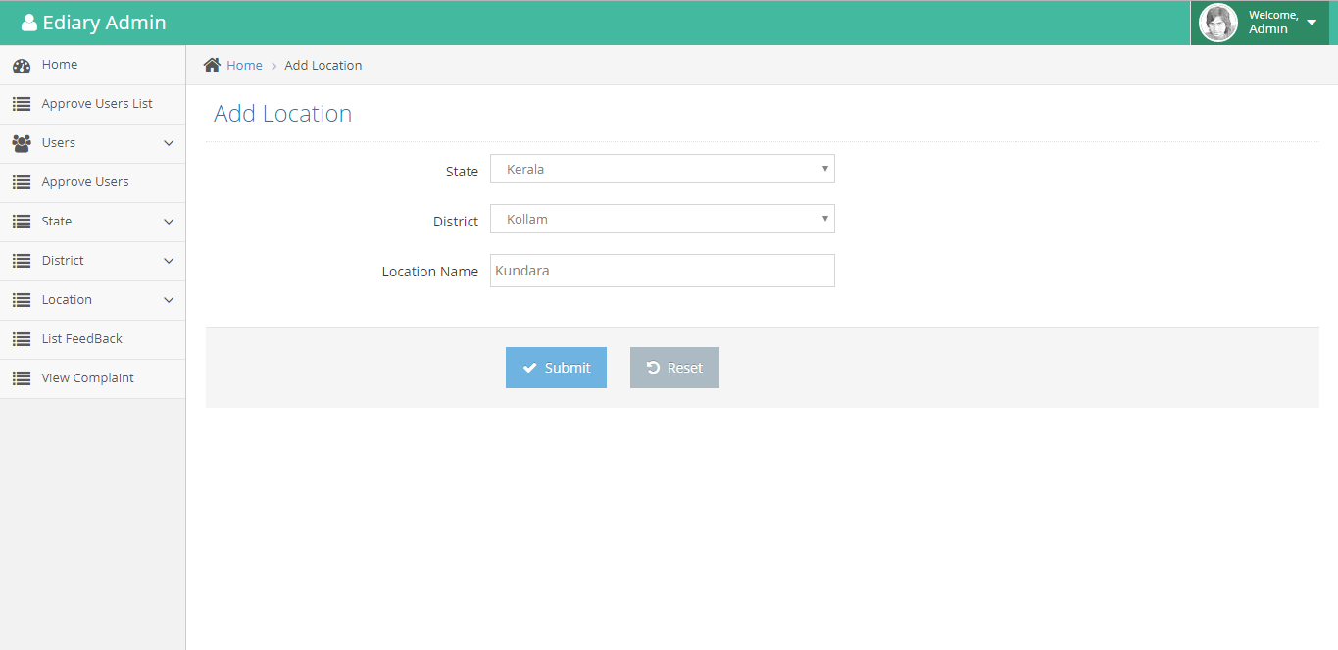
User List
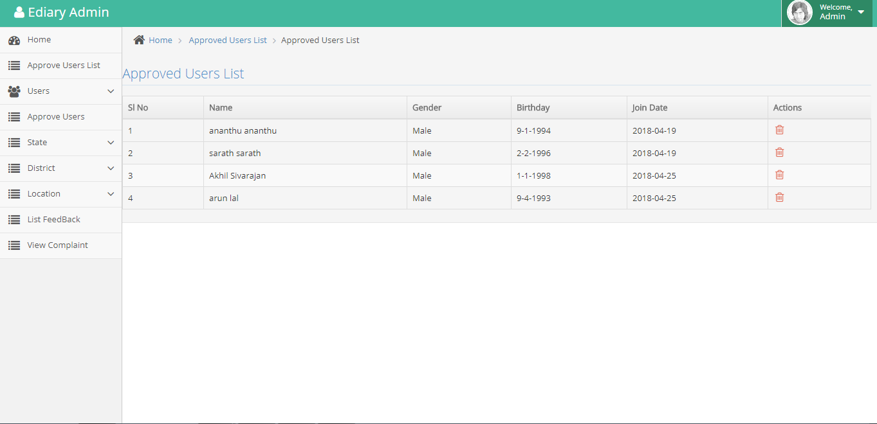
Add State
if(isset($_REQUEST['save']))
{
$a =$_POST['sname'];
$query = "INSERT INTO tbl_state(s_name) VALUES ('$a')";
$res = mysql_query($query);
if($res>0)
{
echo '<script language="javascript">';
echo 'alert("Successfully Added State");location.href="add_state.php"';
echo '</script>';
}
else
{
echo '<script language="javascript">';
echo 'alert("Something went wrong, try again later...");location.href="add_state.php"';
echo '</script>';
}
}
Add District
if(isset($_REQUEST['save']))
{
$a =$_POST['state'];
$b =$_POST['dname'];
$query = "INSERT INTO tbl_district(d_state_id,d_name) VALUES ('$a','$b')";
$res = mysql_query($query);
if($res>0)
{
echo '<script language="javascript">';
echo 'alert("Successfully Added District");location.href="add_district.php"';
echo '</script>';
}
else
{
echo '<script language="javascript">';
echo 'alert("Something went wrong, try again later...");location.href="add_district.php"';
echo '</script>';
}
}
Add Location
if(isset($_REQUEST['save']))
{
$a =$_POST['state'];
$c =$_POST['district'];
$b =$_POST['lname'];
$query = "INSERT INTO tbl_location(l_state_id,l_district_id,l_name) VALUES ('$a','$c','$b')";
$res = mysql_query($query);
if($res>0)
{
echo '<script language="javascript">';
echo 'alert("Successfully Added Location");location.href="add_location.php"';
echo '</script>';
}
else
{
echo '<script language="javascript">';
echo 'alert("Something went wrong, try again later...");location.href="add_location.php"';
echo '</script>';
}
}
User List
<?php
$query="SELECT * from users where user_status='1'";
$result = mysql_query($query);
?>
Login
<?php
if(isset($_POST['Login']))
{
mysql_connect("localhost","root","");
mysql_select_db("faceback");

$user=$_POST['username'];
$pass=md5($_POST['password']);
$que1=mysql_query("select * from users where Email='$user' and Password='$pass'");
$count1=mysql_num_rows($que1);
if($count1>0)
{
$que6=mysql_query("select * from users where Email='$user' and user_status='1'");
$count4=mysql_num_rows($que6);
if($count4>0)
{
session_start();
$_SESSION['tempfbuser']=$user;
$rec6=mysql_fetch_array($que6);
$userid=$rec6[0];
$que2=mysql_query("select * from user_profile_pic where user_id=$userid");
$rec8=mysql_fetch_array($que2);
$_SESSION['image']=$rec8['image'];
$count2=mysql_num_rows($que2);
if($count2>0)
{
$que3=mysql_query("select * from user_secret_quotes where user_id=$userid");
$count3=mysql_num_rows($que3);
if($count3>0)
{
$que4=mysql_query("select * from user_secret_quotes where user_id=$userid");
while($rec=mysql_fetch_array($que4))
{
$que2=$rec[3];
$ans2=$rec[4];
}
if($que2=="" && $ans2=="")
{
header("location:fb_files/fb_step/fb_step3/Secret_Question2.php");
}
else
{
session_start();
$_SESSION['fbuser']=$user;
$query1=mysql_query("select * from users where Email='$user'");
$rec1=mysql_fetch_array($query1);
$userid=$rec1[0];
$_SESSION['login_id']=$rec1[0];
$_SESSION['name']=$rec1[1];
$_SESSION['gender']=$rec1[4];
mysql_query("update user_status set status='Online' where user_id='$userid'");
header("location:fb_files/fb_home/fb_login_step/fb_step1/Secret_Question1.php");
}
}
else
{
header("location:fb_files/fb_step/fb_step2/Secret_Question1.php");
}
}
else
{
while($rec=mysql_fetch_array($que1))
{
$Gender=$rec[4];
}
if($Gender=="Male")
{
header("location:fb_files/fb_step/fb_step1/Step1_Male.php");
}
else
{
header("location:fb_files/fb_step/fb_step1/Step1_Female.php");
}
}
}
else
{
echo '<script language="javascript">';
echo 'alert("You Are Not Approved By Admin");location.href="index.php"';
echo '</script>';
}
}
else
{
$que5=mysql_query("select * from users where Email='$user'");
$count5=mysql_num_rows($que5);

if($count5>0)
{
header("location:index.php");
}
else
{
header("location:index.php");
}
}
}
?>
Search Contacts
session_start();
include("background.php");
if(isset($_SESSION['fbuser']))
{
mysql_connect("localhost","root","");
mysql_select_db("faceback");
$user_email=$_SESSION['fbuser'];
$query=mysql_query("select * from users where Email='$user_email'");

while($row=mysql_fetch_array($query))
{
$user_id=$row['user_id'];
}
require_once './config.php';
include './header.php';

/*******PAGINATION CODE STARTS*****************/
if (!(isset($_GET['pagenum']))) {
$pagenum = 1;
} else {
$pagenum = $_GET['pagenum'];
}
$page_limit = ($_GET["show"] <> "" && is_numeric($_GET["show"]) ) ? $_GET["show"] : 8;

try {
$keyword = trim($_GET["keyword"]);
if ($keyword <> "" ) {
$sql = "SELECT * FROM tbl_contacts WHERE 1 AND "
. " (first_name LIKE :keyword) where user_id='$user_id' ORDER BY first_name ";
$stmt = $DB->prepare($sql);

$stmt->bindValue(":keyword", $keyword."%");

} else {
$sql = "SELECT * FROM tbl_contacts WHERE user_id='$user_id' ORDER BY first_name ";
$stmt = $DB->prepare($sql);
}

$stmt->execute();
$total_count = count($stmt->fetchAll());

$last = ceil($total_count / $page_limit);

if ($pagenum < 1) {
$pagenum = 1;
} elseif ($pagenum > $last) {
$pagenum = $last;
}

$lower_limit = ($pagenum - 1) * $page_limit;
$lower_limit = ($lower_limit < 0) ? 0 : $lower_limit;

$sql2 = $sql . " limit " . ($lower_limit) . " , " . ($page_limit) . " ";

$stmt = $DB->prepare($sql2);

if ($keyword <> "" ) {
$stmt->bindValue(":keyword", $keyword."%");
}

$stmt->execute();
$results = $stmt->fetchAll();
} catch (Exception $ex) {
echo $ex->getMessage();
}
/*******PAGINATION CODE ENDS*****************/
?>

