Ecell

Staff module
- List company:-

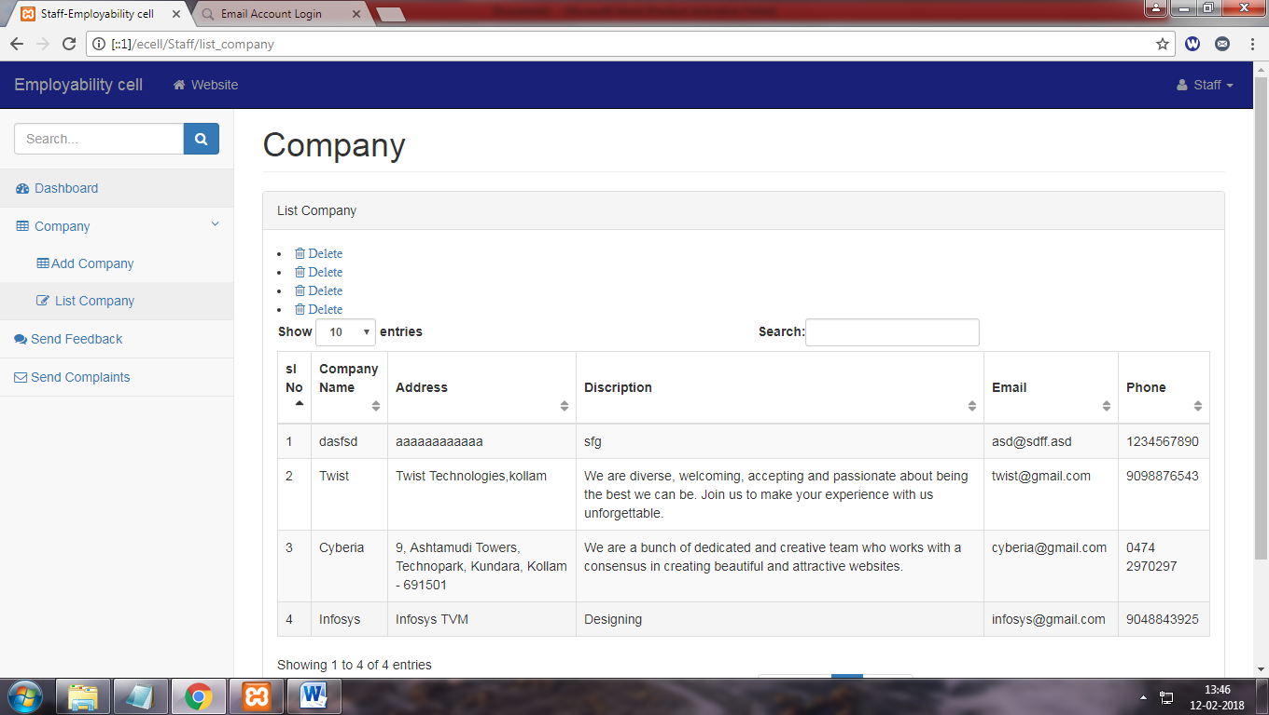

Delete link does not work
- Add company:-
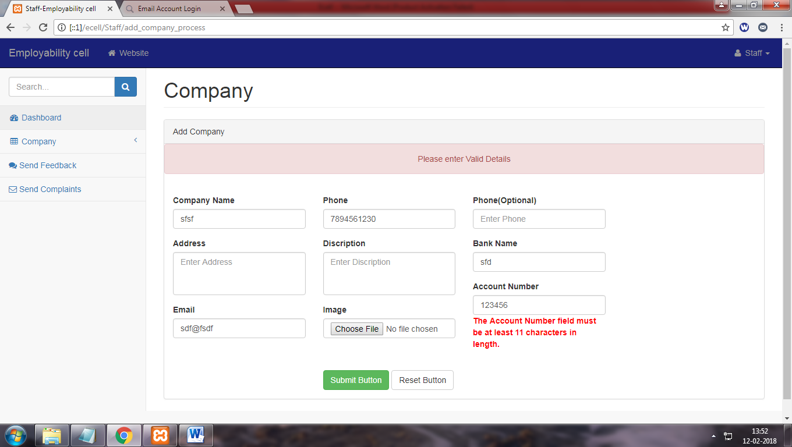

Entered data in address and discription field getting lost when page returns a validation problem
- Change password:-
Does not change old password
- Edit profile:-
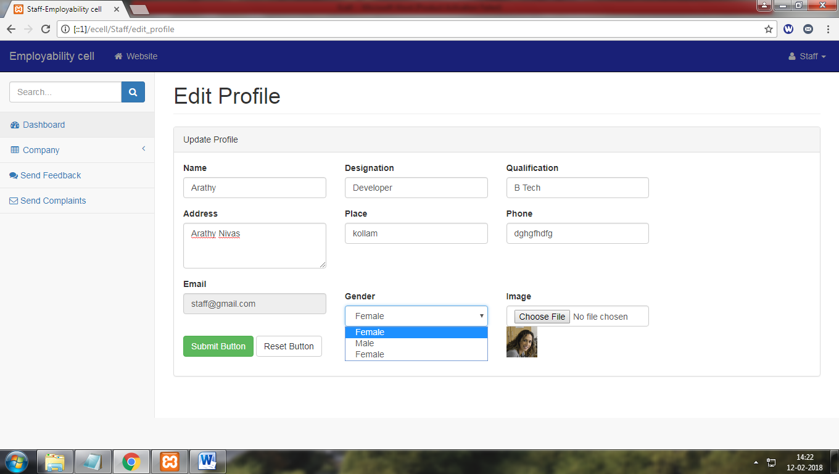

Two female option for gender
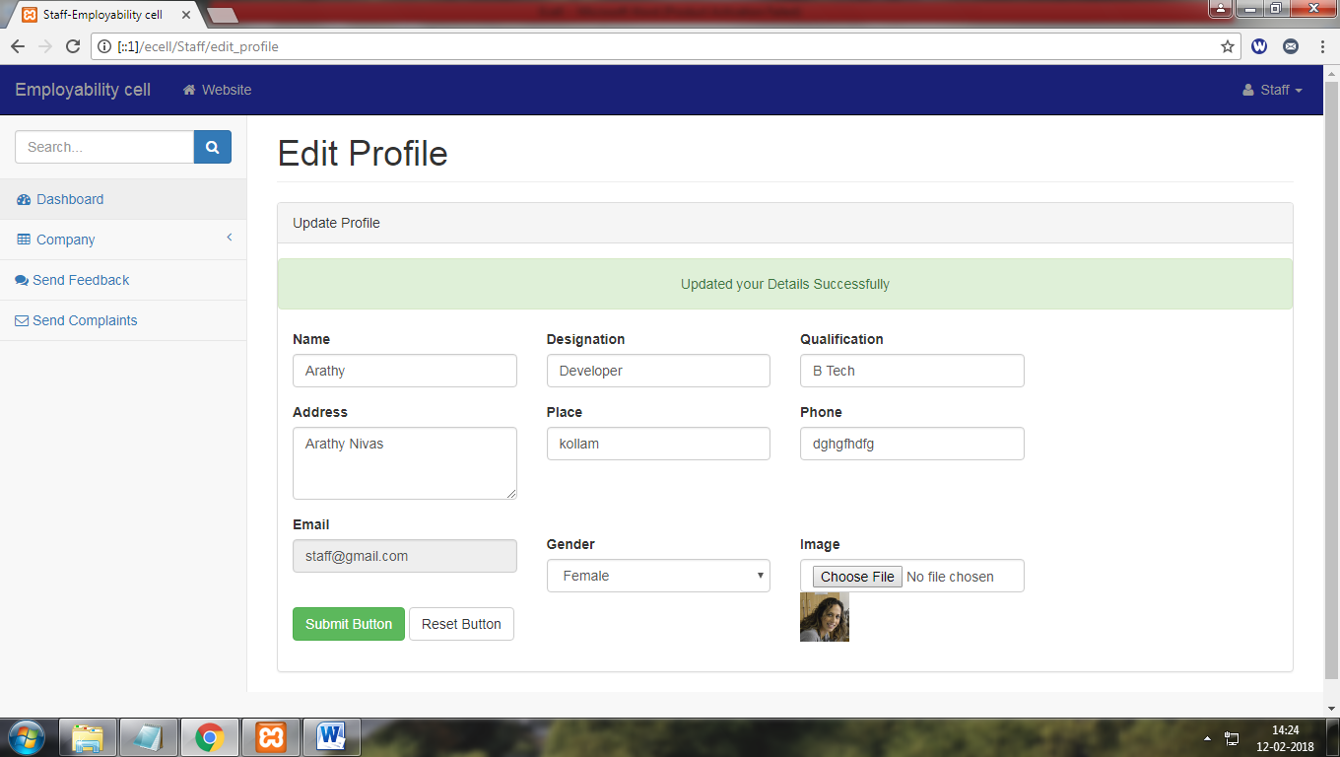

No validation in edit form

Cantidate module
- Login :-
Returning error code in invalid entry

- Homepages

Home1 for candidate


Home 2 for candidate
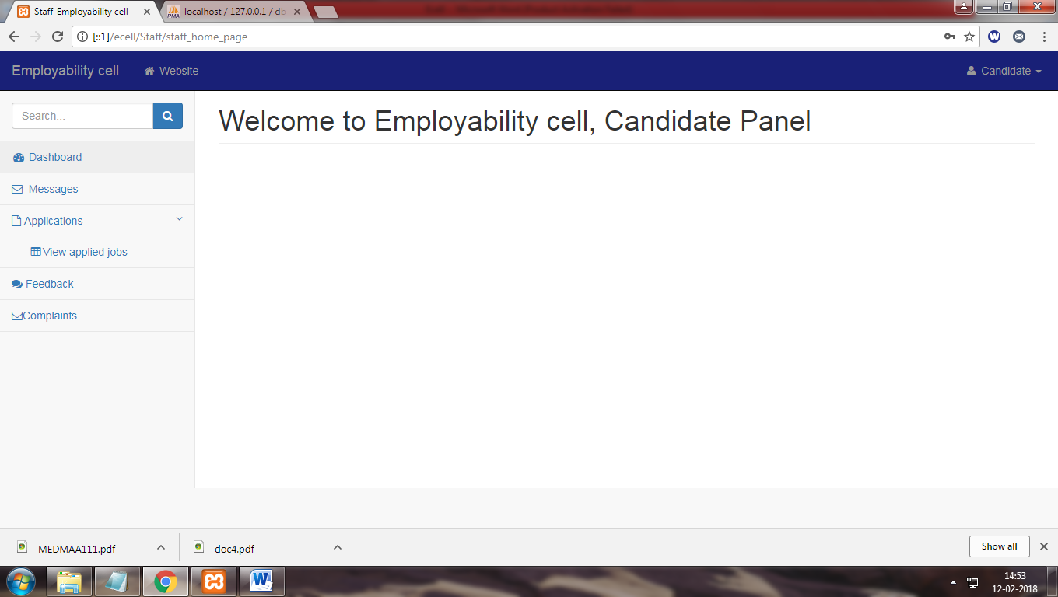

Two independent home pages for one module it seems complicated home 1 conatin activity such as submiting jobapplication ,serch new job etc
And home 2 contain submited job application no like link avilabe to acces home 1 to home2 or home 2 to home1 other than login in with two different login
Login1
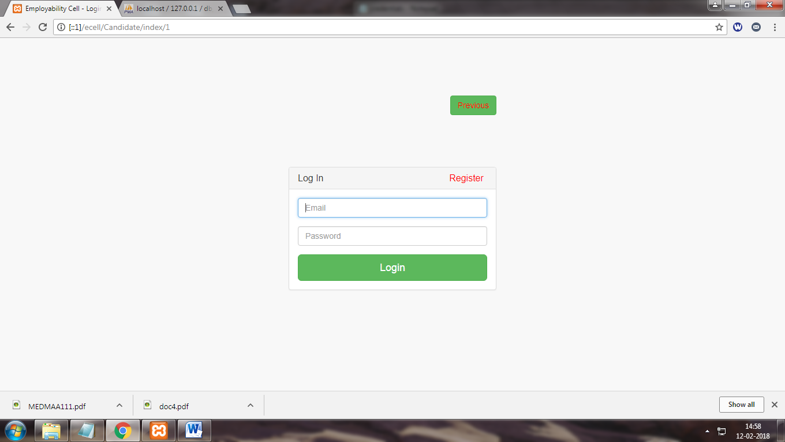

Login2
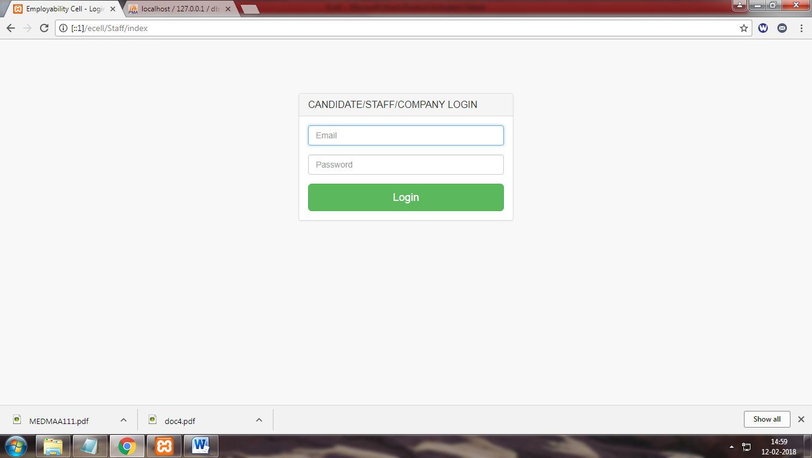
- Registartion:-
No validation applyed
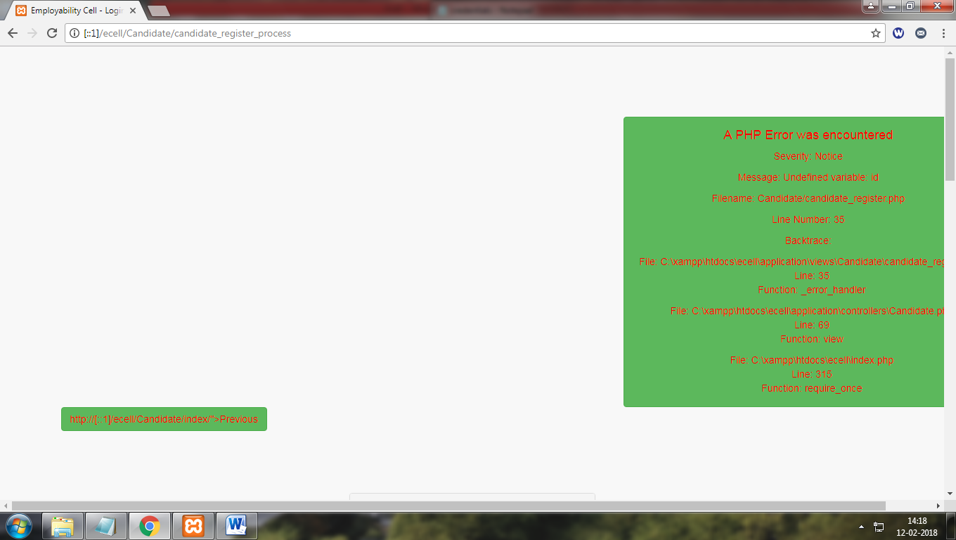

Returning error on submiting the form
- Change password:-
Does not change old password
- Edit profile:-
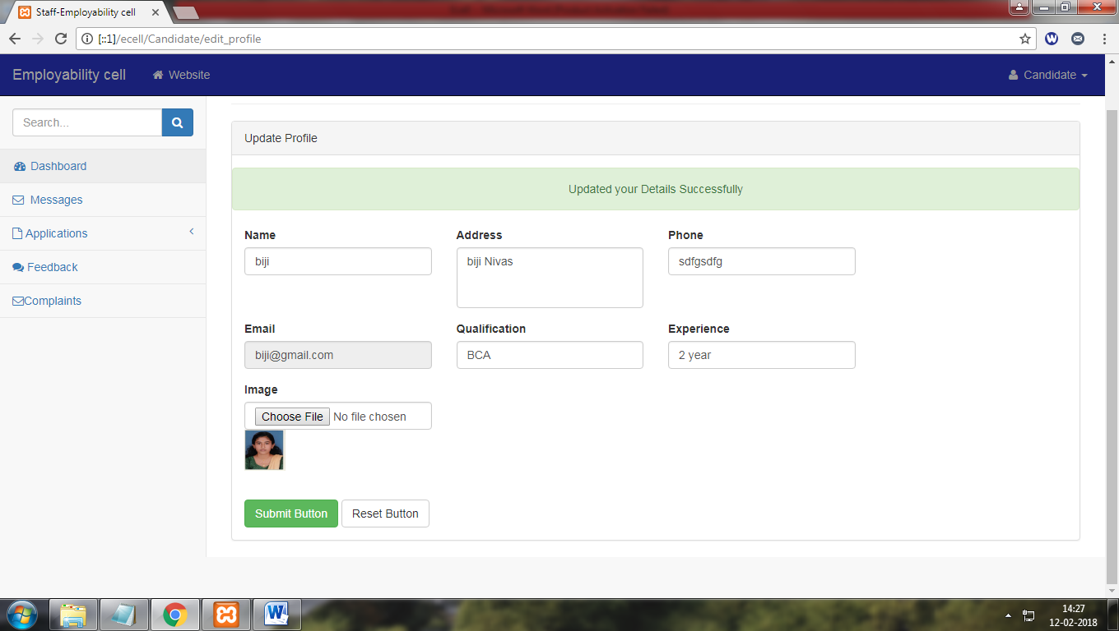
No validation in edit form

Company module

- Change password:-
Does not change old password
- Payment
No payment process available in this module but payment details are available at admin page (for clarification of missing part)

- Add jobs

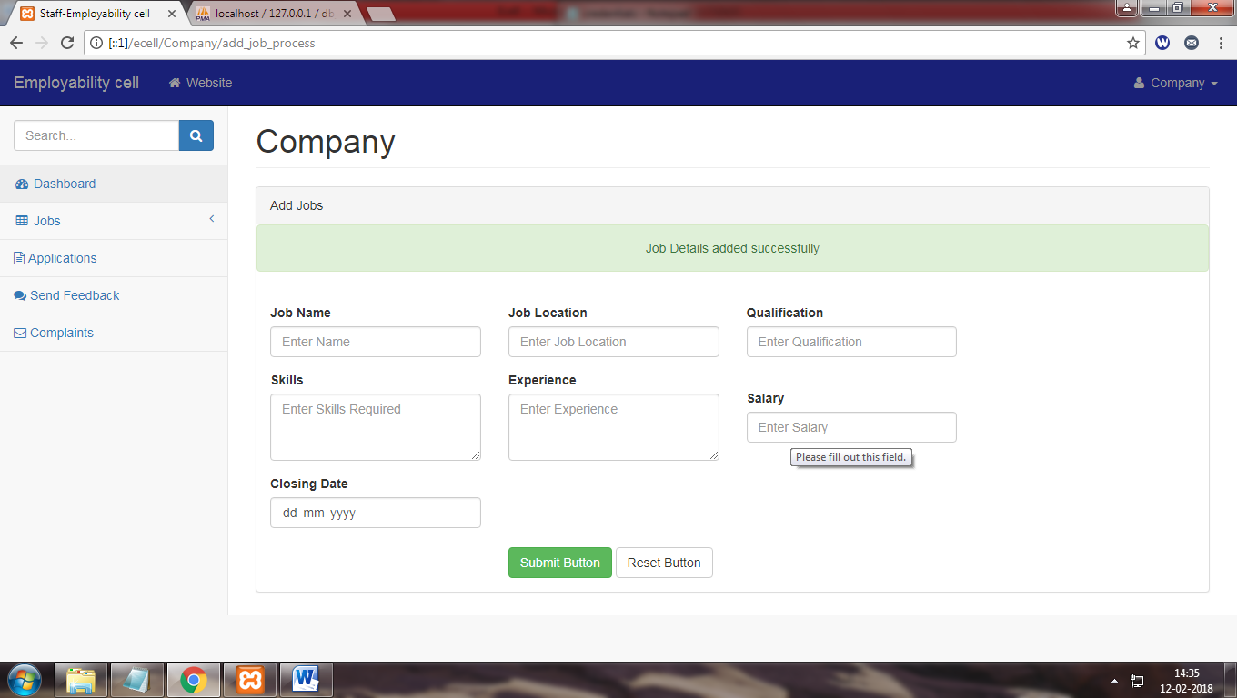
No validation for this form (accept date less than current date ,salary field etc)

- Edit profile
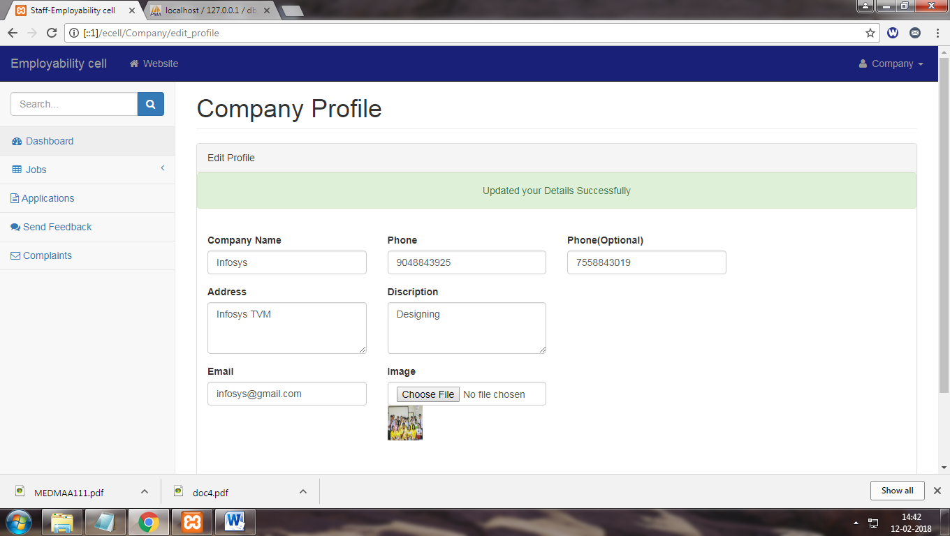
No interaction on validation for this page (no alert message for invalid entry )

Admin module
- Approve company:-
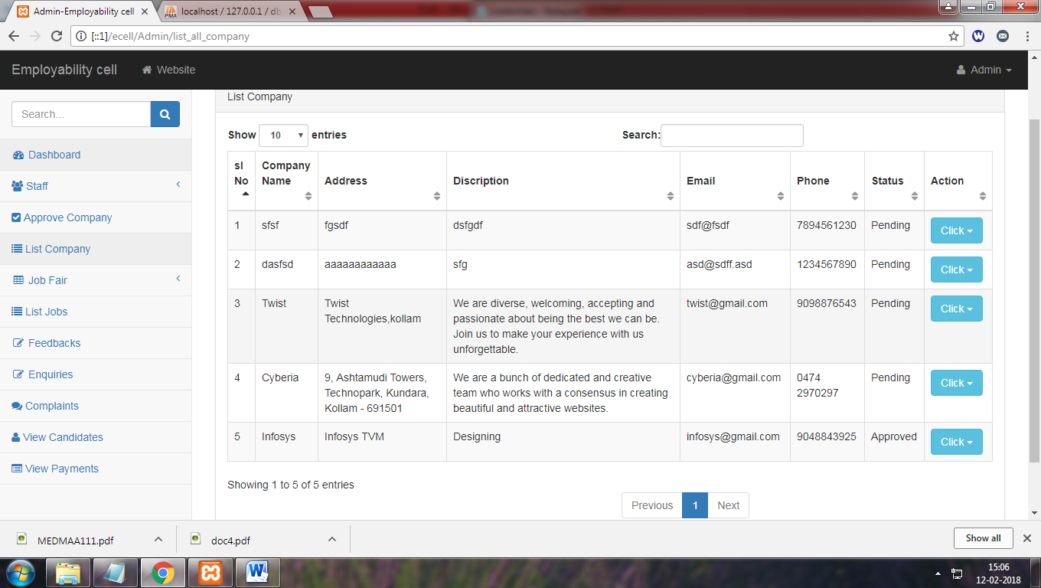
Pending company request are available on list company
But not available in approve company for approvel
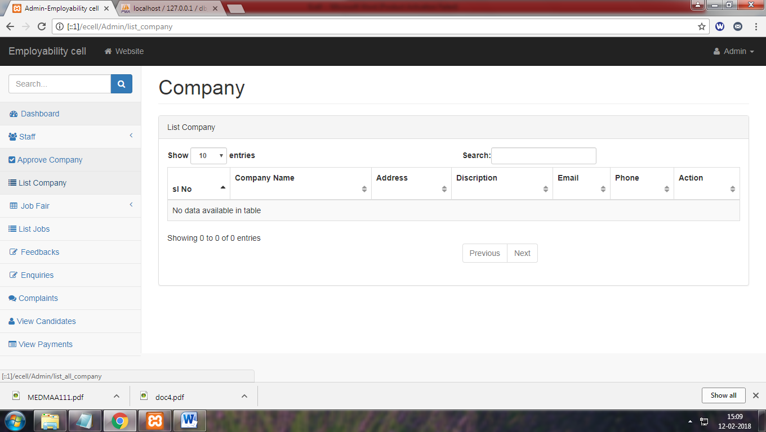

- job fair:-
does not interact or specify which field receive invalid input
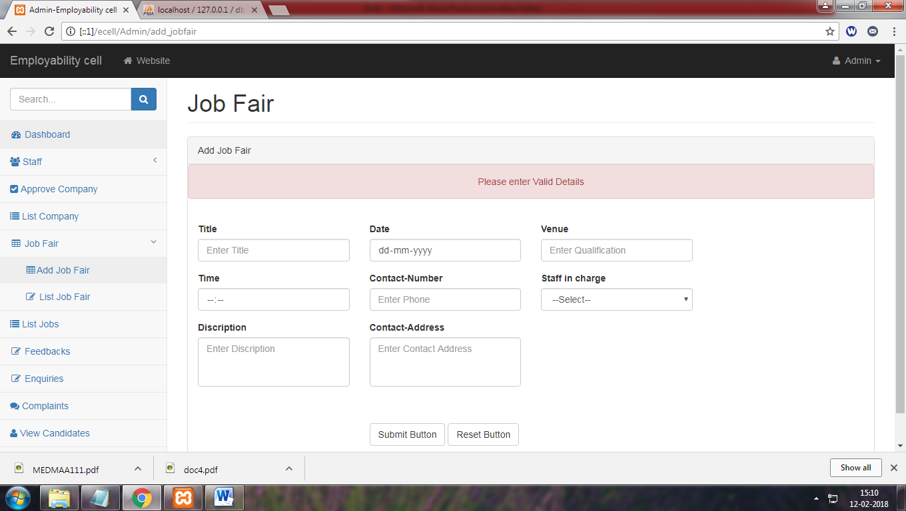
- Edit job fair:-
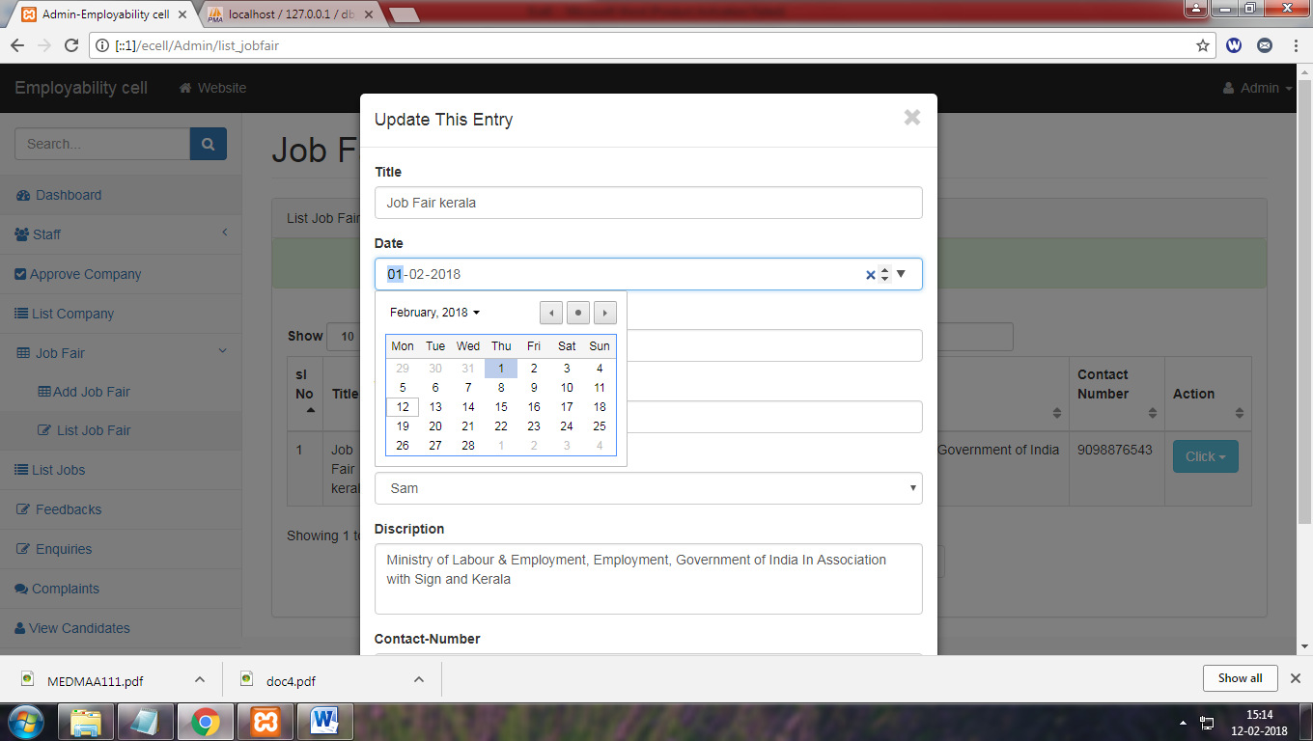
Validation not applied for date fields
- Delete job fair:-
It directed to edit job fair
- View feedback ,compaint:-

Show entres and search box are missing for company and staff

For candidate
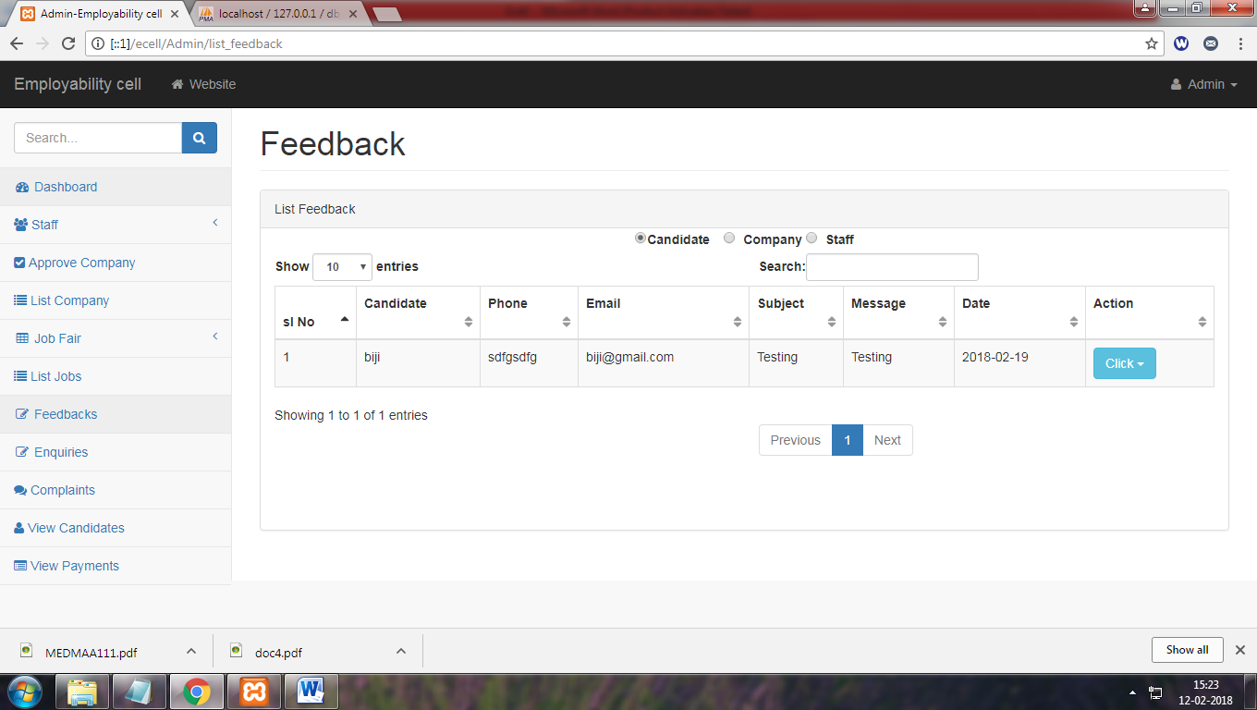

For company and staff
